**Dashboard Design**

| Date | 1 August 2025 |
| --- | --- |
| Team ID |  |
| Project Name | Power BI Inflation Analysis: Journeying Through Global Economic Terrain |
| Maximum Marks | 5 Marks |

Creating an effective dashboard involves thoughtful design to ensure that the presented information is clear, relevant, and easily understandable for the intended audience. Here are some key principles and best practices for dashboard design

**Activity 1: Interactive and visually appealing dashboards**

Creating interactive and visually appealing dashboards involves a combination of thoughtful design, effective use of visual elements, and the incorporation of interactive features. Here are some tips to help you design dashboards that are both visually appealing and engaging for users so take care of below points

* Clear and Intuitive Layout
* Use Appropriate Visualizations
* Colour and Theming
* Interactive Filters and Slicers
* Drill-Down Capabilities
* Responsive Design
* Custom Visuals and Icons
* Use of Infographics

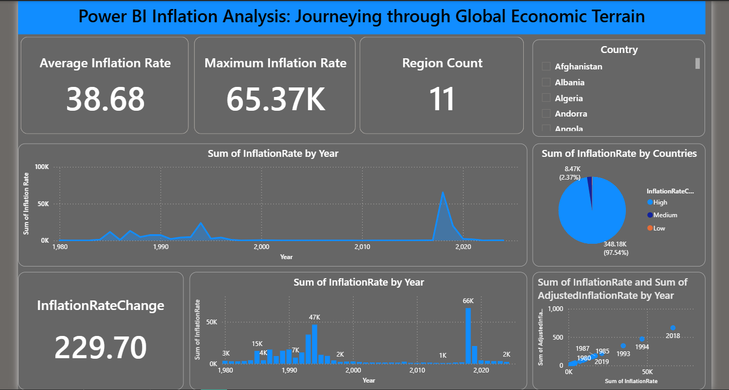

Here are all potential outcomes from the **Global Inflation Power BI Dashboard**:

* **Average Inflation Rate (Card Visualization):** The global average inflation rate is **38.68**, showing the overall inflationary pressure across regions.
* **Maximum Inflation Rate (Card Visualization):** The highest recorded inflation rate is **65,370**, highlighting severe economic instability in some nations.
* **Regional Coverage (Card Visualization):** The dataset spans **11 regions**, offering wide geographic coverage for inflation analysis.
* **Inflation Trends Over Time (Line Chart – Sum of InflationRate by Year):** Clear inflation spikes are visible in the late 1980s, early 1990s, and around **2020**, indicating that major historical and economic events significantly influenced inflation during these years.
* **Inflation Distribution by Category (Pie Chart – Sum of InflationRate by Countries):** The **High** inflation category accounts for **97.54%** of total recorded values, dwarfing Medium and Low categories, which indicates that most inflation figures come from economies under extreme pressure.
* **Inflation Change (Card Visualization – InflationRateChange):** The inflation rate change recorded is **229.70**, showing a considerable shift in inflation levels across the measured period.
* **Combined Inflation Metrics (Scatter Plot – Sum of InflationRate and AdjustedInflationRate by Year):** This plot reveals that years like **1980, 1985, 1987, 1993, 1994, 2018, and 2019** had notable combinations of high nominal and adjusted inflation rates.
* **Yearly Inflation Totals (Bar Chart – Sum of InflationRate by Year):** The highest yearly total inflation rates occurred in the late 1980s, early 1990s, and around 2020, aligning with global and regional economic disruptions.